
Sukkur Institute of Business Administration University
Department of Computer Science

Programming Fundamentals (C++)

BS – I (Computer Science - D)

Fall 2025

Instructor: Nisar Ahmed Siddiqui

LAB # 03

Submission Profile

Name: Abdul Wasio
CMS ID: 023 - 25 - 0007
Date: 11 September 2025
Receiving Authority: Sir Nisar Ahmed Siddiqui

PROGRAMMING FUNDAMENTS
TABLE OF CONTENTS
03
Practice Task 1
04
Practice Task 2
05
Exercise 1

06
Exercise 2

10
Exercise 3 & 4

12
Exercise 5
13
Exercise 6

14

Practice Task 1
Exercise 7

Write a program that generates the following output by using setw, left, right and endl manipulators

Program
#include<iostream>
using namespace std;
int main(){
float num1 , num2,add,sub,multi,div;
cout<<"Enter the Value of Num1 : ";
cin>>num1;
cout<<"\nEnter the Value of Num2 : ";
cin>>num2;
add = num1 + num2;
multi = num1 * num2;
sub = num1 - num2;
div = num1 / num2;
cout<<"\nAddition = "<<add;
cout<<"\nSubtraction = "<<sub;
cout<<"\nMultiplication = "<<multi;
cout<<"\nDivision = "<<div;
return 0;
}
Output
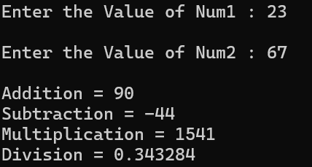

Practice Task 2
Write a program that generates the following output by using setw, left, right and endl manipulators

Program
#include<iostream>
using namespace std;
int main(){
float num1 , num2,add,sub,multi,div;
cout<<"Enter the Value of Num1 : ";
cin>>num1;
cout<<"\nEnter the Value of Num2 : ";
cin>>num2;
add = num1 + num2;
multi = num1 * num2;
sub = num1 - num2;
div = num1 / num2;
cout<<"\nAddition of "<<num1<<" and "<<num2<<" is "<<add;
cout<<"\nSubtraction = "<<num1<<" and "<<num2<<" is "<<sub;
cout<<"\nMultiplication = "<<num1<<" and "<<num2<<" is "<<multi;
cout<<"\nDivision = "<<num1<<" and "<<num2<<" is "<<div;
return 0;
}
Output
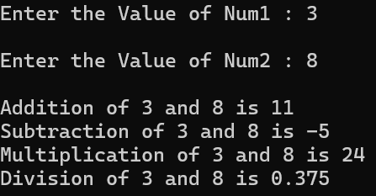

Exercise 1
Write a program that generates the following output by using setw, left, right and endl manipulators

Program
#include<iostream>
#include<iomanip>
using namespace std;
int main(){
cout<<"Programming\n";
cout<<setw(20)<<"Fundamentals\n";
cout<<setw(20)<<"C++\n";
return 0;
}

Output
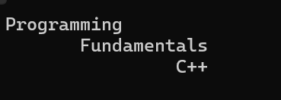

Exercise 2
Write a program to print the following shapes using the setw and endl manipulator only(Don’t use and escape sequence or spaces).

a. | 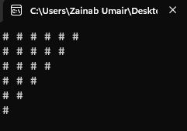 | b. | 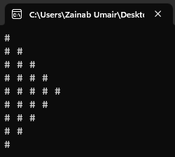
c. | 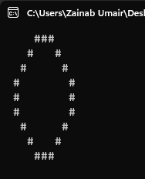 | d. | 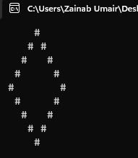

Program (a)
#include<iostream>
#include<iomanip>
using namespace std;
int main(){
cout<<"#"<<setw(2)<<"#"<<setw(2)<<"#"<<setw(2)<<"#"<<setw(2)<<"#"<<setw(2)<<"#";
cout<<"\n#"<<setw(2)<<"#"<<setw(2)<<"#"<<setw(2)<<"#"<<setw(2)<<"#";
cout<<"\n#"<<setw(2)<<"#"<<setw(2)<<"#"<<setw(2)<<"#";
cout<<"\n#"<<setw(2)<<"#"<<setw(2)<<"#";
cout<<"\n#"<<setw(2)<<"#";
cout<<"\n#";
return 0;
}

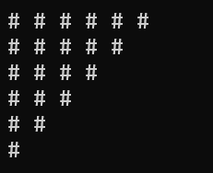
Output

Program (b)
#include<iostream>
#include<iomanip>
using namespace std;
int main(){
cout<<"#";
cout<<"\n#"<<setw(2)<<"#";
cout<<"\n#"<<setw(2)<<"#"<<setw(2)<<"#";
cout<<"\n#"<<setw(2)<<"#"<<setw(2)<<"#"<<setw(2)<<"#";
cout<<"\n#"<<setw(2)<<"#"<<setw(2)<<"#"<<setw(2)<<"#"<<setw(2)<<"#";
cout<<"\n#"<<setw(2)<<"#"<<setw(2)<<"#"<<setw(2)<<"#";
cout<<"\n#"<<setw(2)<<"#"<<setw(2)<<"#";
cout<<"\n#"<<setw(2)<<"#";
cout<<"\n#";
return 0;
}
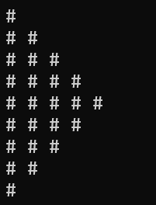
Output

Program (c)
#include<iostream>
#include<iomanip>
using namespace std;
int main(){
cout<<setw(10)<<"###";
cout<<"\n"<<setw(7)<<"#"<<setw(4)<<"#";
cout<<"\n"<<setw(6)<<"#"<<setw(6)<<"#";
cout<<"\n"<<setw(5)<<"#"<<setw(8)<<"#";
cout<<"\n"<<setw(4)<<"#"<<setw(10)<<"#";
cout<<"\n"<<setw(4)<<"#"<<setw(10)<<"#";
cout<<"\n"<<setw(5)<<"#"<<setw(8)<<"#";
cout<<"\n"<<setw(6)<<"#"<<setw(6)<<"#";
cout<<"\n"<<setw(7)<<"#"<<setw(4)<<"#";
cout<<"\n"<<setw(10)<<"###";
return 0;
}


Output

Program (d)
#include<iostream>
#include<iomanip>
using namespace std;
int main(){
cout<<setw(10)<<"#";
cout<<"\n"<<setw(8)<<"#"<<setw(4)<<"#";
cout<<"\n"<<setw(7)<<"#"<<setw(6)<<"#";
cout<<"\n"<<setw(6)<<"#"<<setw(8)<<"#";
cout<<"\n"<<setw(5)<<"#"<<setw(10)<<"#";
cout<<"\n"<<setw(4)<<"#"<<setw(12)<<"#";
cout<<"\n"<<setw(5)<<"#"<<setw(10)<<"#";
cout<<"\n"<<setw(6)<<"#"<<setw(8)<<"#";
cout<<"\n"<<setw(7)<<"#"<<setw(6)<<"#";
cout<<"\n"<<setw(8)<<"#"<<setw(4)<<"#";
cout<<"\n"<<setw(10)<<"#";
return 0;
}

Output
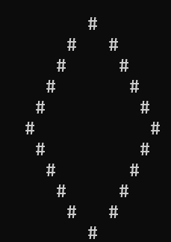

Exercise 3
Write a program that asks the user to input two numbers i.e., num1 and num2;
And the output should be formatted according to these numbers. The larger number will print the larger gap on the screen (use setw and right align).

Program

#include<iostream>
#include<iomanip>
using namespace std;
int main(){
int num1, num2;
cout<<"Enter 1st Value : ";
cin>>num1;
cout<<"\nEnter 2nd Value : ";
cin>>num2;
cout<<setw(num1)<<num1<<" Slots";
cout<<"\n"<<setw(num2)<<num2<<" Slots";
return 0;
}

Output
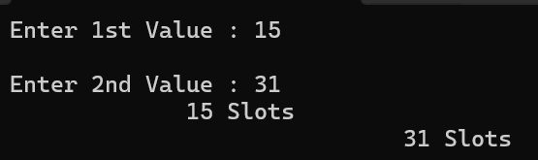

Exercise 4
Generate the below-mentioned output using the Manipulators only (setw(n), endl, fixed, left, etc.)

Program

#include<iostream>
#include<iomanip>
using namespace std;
int main(){
cout<<"=================================\n";
cout<<setw(20)<<"HYPER MALL\n";
cout<<"=================================\n";

cout<<left<<setw(12)<<"Items"<<setw(12)<<"Small"<<setw(12)<<"Medium"<<setw(12)<<"Large"<<endl;
cout<<fixed<<setprecision(2);
cout<<left<<setw(12)<<"Box"<<setw(12)<<"20.50"<<setw(12)<<"40.59"<<setw(12)<<"60.75"<<endl;
cout<<left<<setw(12)<<"Bottle"<<setw(12)<<"18.59"<<setw(12)<<"29.84"<<setw(12)<<"35.75"<<endl;
cout<<left<<setw(12)<<"Socks"<<setw(12)<<"20.50"<<setw(12)<<"50.59"<<setw(12)<<"99.75"<<endl;
cout<<left<<setw(12)<<"Beg"<<setw(12)<<"89.87"<<setw(12)<<"92.87"<<setw(12)<<"99.89"<<endl;
cout<<left<<setw(12)<<"Glass"<<setw(12)<<"70.50"<<setw(12)<<"80.59"<<setw(12)<<"99.75"<<endl;
cout<<left<<setw(12)<<"Ball"<<setw(12)<<"67.89"<<setw(12)<<"58.97"<<setw(12)<<"98.65"<<endl;
cout<<left<<setw(12)<<"Diary"<<setw(12)<<"50.78"<<setw(12)<<"60.50"<<setw(12)<<"50.45"<<endl;
return 0;
}

Output
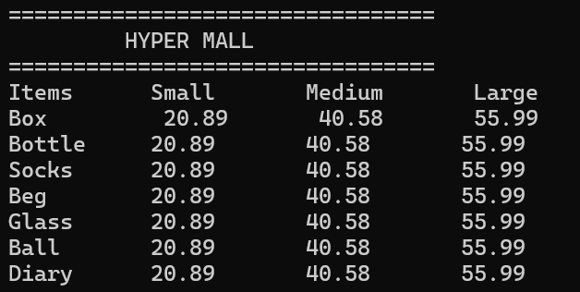

Exercise 5
Write a program in which you create three float variables to set the price of 240.99999 for a joystick, 180.88888 for disk, and 570.77777 for keyboard. Your task is to print the prices of the above-mentioned items in the following format.
NOTE: After decimal points, your program must print two digits.

Program

#include<iostream>
#include<iomanip>
using namespace std;
int main(){
cout<<"=========================================\n";
cout<<setw(20)<<"HYPER MALL\n";
cout<<"=========================================\n";

cout<<left<<setw(12)<<"Items"<<setw(12)<<"Small"<<setw(12)<<"Medium"<<setw(12)<<"Large"<<endl;
cout<<fixed<<setprecision(2);
cout<<left<<setw(12)<<"Box"<<setw(12)<<"20.50"<<setw(12)<<"40.59"<<setw(12)<<"60.75"<<endl;
cout<<left<<setw(12)<<"Bottle"<<setw(12)<<"18.59"<<setw(12)<<"29.84"<<setw(12)<<"35.75"<<endl;
cout<<left<<setw(12)<<"Socks"<<setw(12)<<"20.50"<<setw(12)<<"50.59"<<setw(12)<<"99.75"<<endl;
cout<<left<<setw(12)<<"Beg"<<setw(12)<<"89.87"<<setw(12)<<"92.87"<<setw(12)<<"99.89"<<endl;
cout<<left<<setw(12)<<"Glass"<<setw(12)<<"70.50"<<setw(12)<<"80.59"<<setw(12)<<"99.75"<<endl;
cout<<left<<setw(12)<<"Ball"<<setw(12)<<"67.89"<<setw(12)<<"58.97"<<setw(12)<<"98.65"<<endl;
cout<<left<<setw(12)<<"Diary"<<setw(12)<<"50.78"<<setw(12)<<"60.50"<<setw(12)<<"50.45"<<endl;
return 0;
}
Output
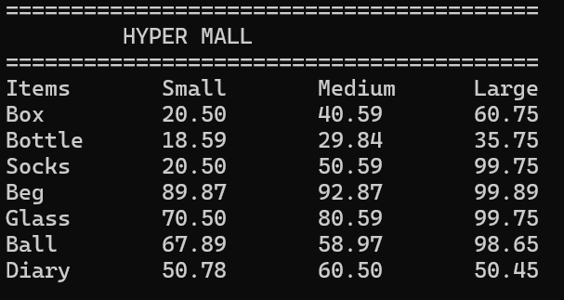

Exercise 6
Make a program in which it asks form user to enter total amount, you have to answer how much INTEREST to be paid on that amount. INTEREST is the 14.5% of the total amount. Hint: In order to calculate the INTEREST of 14.5% is (14.5/100*n), where n is the amount given by the user.

Program

#include<iostream>
using namespace std;
int main(){
int amount , interst;
cout<<"Enter the Amount : ";
cin>>amount;
interst = amount*0.145; //14.5/100
cout<<"The Interst on the "<<amount<<" is "<<interst;
return 0;

}

Output
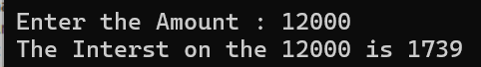

Exercise 7
Write a program for the marksheet, where user should be able to enter the marks for five subjects. Then, your program should tell him/her his/her obtained marks, average marks and percentage.
Note: You can assume each subject to be of 100 marks. So, the total marks would become 500 for five subjects. While printing the final Marksheet it must contain your name and CMS-ID as student name and CMS-ID.

Program

#include<iostream>
#include<iomanip>
using namespace std;
int main(){
int pf, ict , oop ,maths , english ,cms , total , avrg ;
float percent;
cout<<"Enter Your PF Marks : ";
cin>>pf;
cout<<"\nEnter Your ICT Marks : ";
cin>>ict;
cout<<"\nEnter Your OOP Marks : ";
cin>>oop;
cout<<"\nEnter Your Maths Marks : ";
cin>>maths;
cout<<"\nEnter Your Englsih Marks : ";
cin>>english;
cout<<"\n\n";
total = pf + ict + maths + english + oop;
avrg = ( pf + ict + maths + english + oop)/5;
percent = (total/500.0)*100;

cout<<setfill('*')<<setw(120)<<"*";
cout<<"\n*"<<setfill(' ')<<setw(119)<<"*";
cout<<"\n*"<<setw(60)<<"MARKSHEET"<<setfill(' ')<<setw(59)<<"*";
cout<<"\n*"<<setfill(' ')<<setw(120)<<"*\n";
cout<<setfill('*')<<setw(120)<<"*"<<endl;
cout<<"* Student Name "<<":"<<" Abdul Wasio"<<setfill(' ')<<setw(93)<<"*\n";
cout<<"* CMS ID "<<":"<<"023-25-0007"<<setfill(' ')<<setw(100)<<"*\n";
cout<<setfill('*')<<setw(120)<<"*";
cout<<setfill(' ')<<"\n*"<<setw(15)<<"SUBJECT"
<<setw(30)<<"MIN MARKS"
<<setw(30)<<"OBT MARKS"
<<setw(30)<<"PERCENT"<<setw(15)<<"*\n";
cout<<setfill('*')<<setw(120)<<"*";
cout<<"\n*"<<setfill(' ')<<setw(10)<<"PF"<<setw(31)<<"33"<<setw(31)<<pf<<setw(31)<<pf<<"%"<<setw(15)<<"*";
cout<<"\n*"<<setfill(' ')<<setw(10)<<"ICT"<<setw(31)<<"33"<<setw(31)<<ict<<setw(31)<<ict<<"%"<<setw(15)<<"*";
cout<<"\n*"<<setfill(' ')<<setw(10)<<"OOP"<<setw(31)<<"33"<<setw(31)<<oop<<setw(31)<<oop<<"%"<<setw(15)<<"*";
cout<<"\n*"<<setfill(' ')<<setw(10)<<"ENGLISH"<<setw(31)<<"33"<<setw(31)<<english<<setw(31)<<english<<"%"<<setw(15)<<"*";
cout<<"\n*"<<setfill(' ')<<setw(10)<<"MATHS"<<setw(31)<<"33"<<setw(31)<<maths<<setw(31)<<maths<<"%"<<setw(16)<<"*\n";
cout<<setfill('*')<<setw(119)<<"*"<<"*";
cout<<"\n*"<<setfill(' ')<<setw(30)<<"TOTAL OBT: MARKS : "<<total<<setw(25)<<"AVRG: MARKS : "<<avrg<<setw(25)<<"PERCENTAGE : "<<percent<<"%"<<setw(30)<<"*\n";
cout<<setfill('*')<<setw(119)<<"*"<<"*\n";
return 0;

}

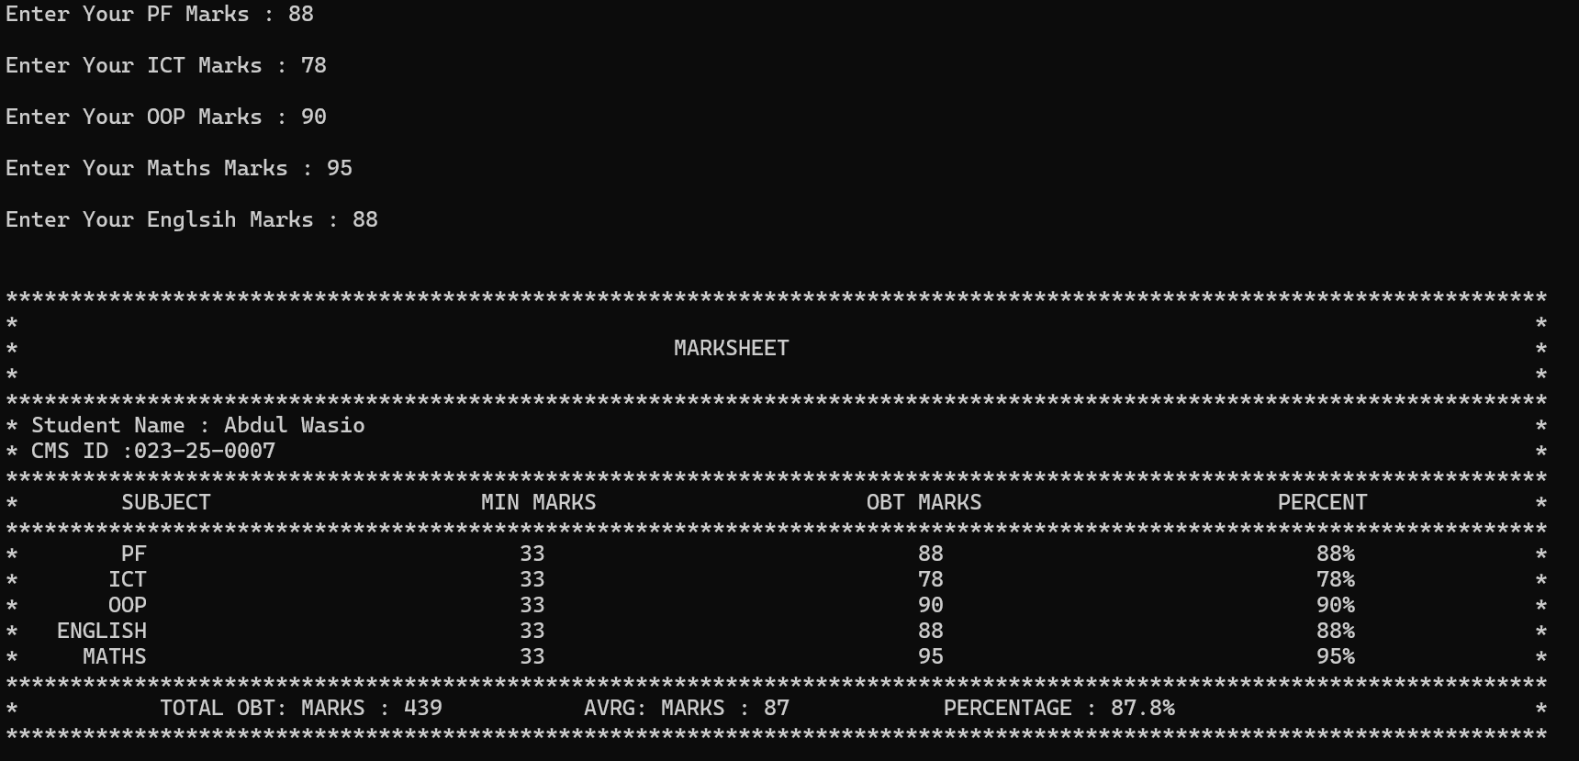
Output

